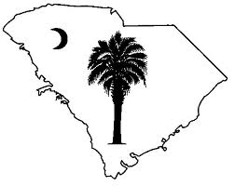
November is Native American Heritage Month!

The South Carolina Commission for Minority Affairs-Native American Affairs has compiled a list of Heritage Month events occurring throughout the State. Also included with this calendar are links to proclamations, information, teaching aids and tribal communities. We encourage all of South Carolina’s citizens to celebrate the rich and diverse heritage of our State’s Indigenous People.

President’s Proclamation: https://www.whitehouse.gov/presidential-actions/

Library of Congress’ Native American Heritage Month Information: http://nativeamericanheritagemonth.gov/about/
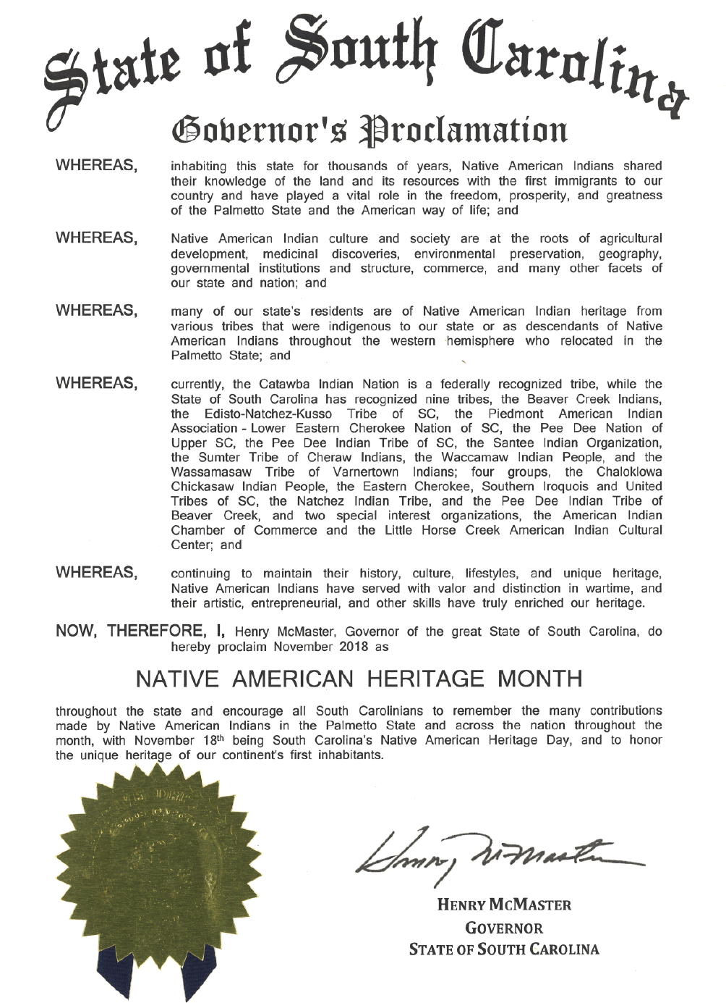
South Carolina Governor’s Proclamation:
See attached full size copy following the calendar.

South Carolina Commission for Minority Affairs Website:
Native American Heritage Month Spotlights
https://cma.sc.gov/minority-population-initiatives/native-american-affairs

United States Department of Agriculture-Natural Resource Conversation Services American Indian and Alaskan Native Heritage Month Poster
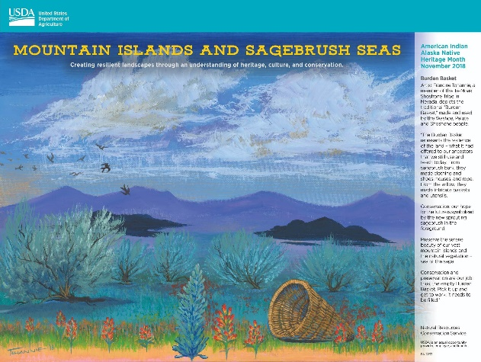
Posters are available by request at the SC Commission for Minority Affairs.

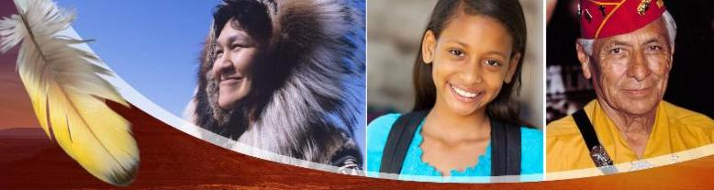
Native American Heritage Month Calendar 2018

Date | Event | Location/Contact Information
All Month | Native American Studies Center Galleries  Tuesday through Saturday | Native American Studies Center  USC-Lancaster  All events are free and open to the public. The USCL Native American Studies Center is located at 119 S. Main Street in downtown Lancaster. For more information, call 803-313-7172 or email criswese@mailbox.sc.edu.  Website:  https://sc.edu/about/system_and_campuses/lancaster/study/student_opportunities/native_american_studies_center/index.php
All Month | Hagood Creek Petroglyph Site  Wednesday, Friday, and Saturday  10:00am-4:00pm | Hagood Creek Petroglyph Site of SC  Enjoy nature, history and prehistoric rock art created by Southeastern Native American Indians at Hagood Mill. Open to the public three days each week, Wednesday, Friday, and Saturday from 10am-4pm. On Wednesday and Friday the site is free to visitors with no parking charge. On third Saturday of the month, there is a $5 parking fee.  Address:  138 Hagood Mill Rd  Pickens, SC 29671  Phone:  (864) 898-2936  Website:  http://www.visitpickenscounty.com/vendor/61/historic-hagood-mill-folklife-center/
Oct. 26th | Native American Studies Center Galleries: Artist-in-Residence-Beckee Garris:  Friday  10:00am-4:00pm | Native American Studies Center  USC-Lancaster  Join the Center’s Artist-in-Residence, Beckee Garris, as she demonstrates pottery and basket making. She will share Catawba oral histories and traditions. Garris will be at the Center between 10:00 am and 4:00 pm.  All events are free and open to the public. The USCL Native American Studies Center is located at 119 S. Main Street in downtown Lancaster. For more information, call 803-313-7172 or email criswese@mailbox.sc.edu.
Oct. 27th | Nature and Art Day  Saturday  11:00 a.m. - 1:00 p.m. | Stevens Park  Kershaw, SC  Join Catawba Artist Beckee Garris for demonstrations, story-telling and selling her work at the Kershaw Community Park Council’s Nature and Art Day!  The event occurs from 11:00 a.m. to 1:00 p.m. at Stevens Park Located at 200 Close Circle Kershaw, S.C. 29067  Sponsor: Native American Studies Center at USC-Lancaster.
Oct. 27th | Catawba 25th Annual Restoration Festival  Saturday  10:00 a.m. -2:00 p.m. | Catawba Indian Nation  Rock Hill, SC  All Tribal Citizens and Tribal Households of the Catawba Indian Nation are invited to come share in a day of celebration of their accomplishments over the past 25th years and enjoy sharing in cultural experiences and activities. This event is not open to the public.  For more information about the Catawba Indian Nation, please visit: https://catawbaindian.net/
Oct. 31st | Native American Studies Center Galleries: Artist-in-Residence-Beckee Garris:  Wednesday  10:00am-4:00pm | Native American Studies Center  USC-Lancaster  Join the Center’s Artist-in-Residence, Beckee Garris, as she demonstrates pottery and basket making. She will share Catawba oral histories and traditions. Garris will be at the Center between 10:00 am and 4:00 pm.  All events are free and open to the public. The USCL Native American Studies Center is located at 119 S. Main Street in downtown Lancaster. For more information, call 803-313-7172 or email criswese@mailbox.sc.edu.
Nov. 3rd-4th | Waccamaw Indian People 26th Annual Cultural Arts Festival & Pauwau  Saturday and Sunday  11:00am | Waccamaw Indian People Tribal Grounds  Anyor, SC  The 26th Annual Cultural Arts Festival & Pauwau will be held Saturday, November 3rd and Sunday, November 4th, 2018 at the tribal grounds, 591 Bluewater Rd, Aynor, SC. The gates will open at 11:00 a.m. on both days. There will be two Grand Entries with one on Saturday, held at 1:00 p.m. and one on Sunday at 2:00 p.m.  Open to the public.  Host Drum: Red Oak  MC: John Blackfeather  For more information, visit https://www.waccamaw.org/single-post/2018/09/23/Waccamaw-Pauwau-2018
Nov. 9th | Native American Studies Center Galleries: Artist-in-Residence-Beckee Garris:  Friday  10:00am-4:00pm | Native American Studies Center  USC-Lancaster  Join the Center’s Artist-in-Residence, Beckee Garris, as she demonstrates pottery and basket making. She will share Catawba oral histories and traditions. Garris will be at the Center between 10:00 am and 4:00 pm.  All events are free and open to the public. The USCL Native American Studies Center is located at 119 S. Main Street in downtown Lancaster. For more information, call 803-313-7172 or email criswese@mailbox.sc.edu.
Nov. 10th | 39th Annual Veteran’s Day Parade- American Indian Unit | Downtown-Main Street,  Columbia, SC  The American Indian Center of South Carolina has been sponsoring this unit for over 20 years. The unit consists of Native American Indian people from across the state of South Carolina. This year's unit is dedicated to the memory of veterans of various tribes.  More details to come as they are available! Bag lunches will be available at the Vietnam Memorial, as usual! Hope to see you there! For more information, call Ms. Judy Rabon at 803-960-9437 or email at jmorabon@gmail.com. You can also visit their Facebook event page at https://www.facebook.com/events/364705950618723/?active_tab=discussion.
Nov. 10th | Native American Studies Center Galleries: Artist-in-Residence-Beckee Garris:  Saturday  10:00am-4:00pm | Native American Studies Center  USC-Lancaster  Join the Center’s Artist-in-Residence, Beckee Garris, as she demonstrates pottery and basket making. She will share Catawba oral histories and traditions. Garris will be at the Center between 10:00 am and 4:00 pm.  All events are free and open to the public. The USCL Native American Studies Center is located at 119 S. Main Street in downtown Lancaster. For more information, call 803-313-7172 or email criswese@mailbox.sc.edu.
Nov. 10th | 5th Annual Trail of Tears Memorial Walk sponsored by PAIA/Lower Eastern Cherokee Nation of SC  Saturday  11:00am-1:30pm | Ninety Six National Historic Site  Ninety Six, SC  Join the PAIA/Lower Eastern Cherokee Nation of SC in honoring Native American Heritage Month and Awareness Day by remembering the Trial of Tears. The Memorial Walk is located at Ninety Six National Historic Site located 1103 Highway 248 S, Ninety Six, South Carolina 29666. The Tribe will walk along the Cherokee Path at Ninety-Six Historic site to remember our people who were forced from their homes and marched to Present day Oklahoma. For more information visit: https://www.facebook.com/events/630396727344801/
Nov. 10th | Sumter Tribe of Cheraw Indians Cultural Festival  Saturday  11:00am-3:00pm | Sumter Tribe of Cheraw Indians Cultural Festival  Sumter, SC  Join us for an afternoon of fellowship and enlightenment at the Sumter Tribe of Cheraw Indians Cultural Festival on November 10, 2018 at the Sumter County Museum from 11:00am until 3:00pm.  Enjoy Native American art, music and dancing! Snacks and beverages will be available for purchase so no coolers please. Speakers and displays will be relating the history and traditions associated with the Native Americans living in Sumter County.  No charge for attending but tickets for a general raffle will be available for purchase. All proceeds will benefit The Sumter Tribe of Cheraw Indians. Our website is in the process of being updated with the event information. It is http://www.thesumtertribeofcherawindians.org/.  Hosted by The Sumter Tribe of Cheraw Indians with support from the Sumter County Cultural
Nov. 14th-17th | 75th Annual Meeting of the Southeastern Archaeological Conference | Augusta Marriott Convention Center  Augusta, GA  Located in Augusta, Georgia at the Augusta Marriott Convention Center on the Savannah River waterfront level. Tribal Member Registration: Free (with Tribally Issued Identification or CDIB card). For more information, visit https://www.southeasternarchaeology.org/annual-meeting/details/ .
Nov. 16th | Lunch and Learn Series: "To Keep the Indians in Awe': The Conundrum of Cherokee Violence during the California Gold Rush"  Friday  12:00pm | Native American Studies Center  USC-Lancaster  Lunch and Learn Series lecture on "To Keep the Indians in Awe': The Conundrum of Cherokee Violence during the California Gold Rush" by Dr. Rose Stremlau, Davidson College, North Carolina. Flyer attached.  All events are free and open to the public. The USCL Native American Studies Center is located at 119 S. Main Street in downtown Lancaster. For more information, call 803-313-7172 or email criswese@mailbox.sc.edu.
Nov. 16th | Native American Studies Center Galleries: Artist-in-Residence-Beckee Garris:  Friday  10:00am-4:00pm | Native American Studies Center  USC-Lancaster  Join the Center’s Artist-in-Residence, Beckee Garris, as she demonstrates pottery and basket making. She will share Catawba oral histories and traditions. Garris will be at the Center between 10:00 am and 4:00 pm.  All events are free and open to the public. The USCL Native American Studies Center is located at 119 S. Main Street in downtown Lancaster. For more information, call 803-313-7172 or email criswese@mailbox.sc.edu.
Nov. 17th | Native American Studies Center Galleries: Artist-in-Residence-Beckee Garris:  Tuesday  10:00am-4:00pm | Native American Studies Center  USC-Lancaster  Join the Center’s Artist-in-Residence, Beckee Garris, as she demonstrates pottery and basket making. She will share Catawba oral histories and traditions. Garris will be at the Center between 10:00 am and 4:00 pm.  All events are free and open to the public. The USCL Native American Studies Center is located at 119 S. Main Street in downtown Lancaster. For more information, call 803-313-7172 or email criswese@mailbox.sc.edu.
Nov. 17th | Catawba Indian Nation 4th Annual Craft and Food Fair-“Fall Harvest Fest”  Saturday  10:00am-4:00pm | Catawba Indian Nation Longhouse  Rock Hill, SC  Celebrate Native American Heritage Month and Awareness Day with the Catawba Indian Nation at their reservation Longhouse located at 996 Avenue of the Nations Rock Hill, SC. This event will have Native American Vendors, Pottery and Beadwork, Arts and Crafts, Drumming and Dancing, Catawba Language Presentations, Food tasting contests, and more.  Open to the public!  Sponsored by Catawba Service Unit, Catawba Cultural Preservation Project & Wellness Warriors  For more information, please contact Ashely Sexton 803-328-2427 for cultural information; food contest contact Lisa Martin 803-372-5663 & Tolani Franks 803-280-2545 for all other questions. You can also visit: https://www.facebook.com/87272816029/photos/a.10152429054126030/10157375734461030/?type=3&theater .
Nov. 17th | Native American History Lantern Tour  6:00pm-8:00pm | 12,000 Year History Park at Cayce Riverwalk 12,000 Year Trail  Cayce, SC  Celebrate Native American Heritage Month and Awareness Day with a candlelight walk with volunteers in period attire to learn about the lifeways and strategic roles Native Americans played in the economy and welfare of the Carolina colony and later periods.  Learn about varied cultures and traditions of peoples who lived in the area beginning about 12,000 years ago and how their culture and traditions are alive and well in South Carolina today.  We recommend you wear comfortable shoes. For more information, visit: https://www.facebook.com/12000YearHistoryPark/
Nov. 17th | Pee Dee Indian Tribe’s Annual Tribal Gathering  Saturday  11:00am | Pee Dee Tribe  Bennettsville, SC  The Pee Dee Indian Tribe will host its Annual Tribal Gathering on November 17th starting at 11:00am at the Tribal Office located at 134 Longer Sands Road, Bennettsville, SC. Tribal members and guests will enjoy food and fellowship.  For more information, visit their website at http://www.peedeetribe.org/ or Facebook page at https://www.facebook.com/peedeeindiantribe/
Nov. 18th | Native American Heritage Awareness Day | Along with the Native American Heritage Month Celebrations, the State has also set aside November 18th as Native American Heritage Awareness Day to bring awareness to the unique culture and heritage of Native American Indians and issues that affect Native American Communities. The SC Commission for Minority Affairs encourages you to attend one of the many events happening around the State. For more information, please contact Marcy Hayden at mhayden@cfma.sc.gov or visit www.cma.sc.gov.
Nov. 30th | Native American Studies Center Galleries: Artist-in-Residence-Beckee Garris:  Friday  10:00am-4:00pm | Native American Studies Center  USC-Lancaster  Join the Center’s Artist-in-Residence, Beckee Garris, as she demonstrates pottery and basket making. She will share Catawba oral histories and traditions. Garris will be at the Center between 10:00 am and 4:00 pm.  All events are free and open to the public. The USCL Native American Studies Center is located at 119 S. Main Street in downtown Lancaster. For more information, call 803-313-7172 or email criswese@mailbox.sc.edu.
Dec. 1st | Native American Art and Craft Winter Sale  Saturday  9:00am-4:00pm | Native American Studies Center  USC-Lancaster  Native American Art and Craft Sale Just in time for the holiday season, see and shop for jewelry, Catawba pottery, baskets, quilts, and more one-of-a-kind artwork at the sixth annual festival, held in conjunction with the City of Lancaster's Christmas in the City. During the festival, visitors also will have the opportunity to see Artist-in-Residence Beckee Garris and speak with her about her pottery and basket making techniques. Flyer attached.  Native American Studies Center  119 South Main Street, Lancaster, SC 29721  For more information email USCLNASP@mailbox.sc.edu or call (803) 313-7172.

If your event has not been included, or you would like to add an event, please contact Marcy L. Hayden as soon as possible so it can be sent out on the list serve. Contact Information: (803) 832-8165 or mhayden@cfma.sc.gov.

